## PHASE IV REPORT OF PROJECT ON

***FOOD ORDERING SYSTEM***

## SUBMITTED IN THE FULFILLMENT OF THE REQUIREMENT FOR THE AWARD OF THE DEGREE OF

**SEMESTER-5**

***Submittedby:***

*Tushar Rathi (20BCS5183) Jay Prakash Jha (20BCS5070) Rajat Kalotra (20BCS4878)*

# SECTION: 20BCS_WM-603

***in partial fulfillment for the award of the degree of***

# BACHELOR OF ENGINEERING IN

**COMPUTER SCIENCE AND ENGINEERING (BE-CSE)**

*DEPARTMENT OF COMPUTER SCIENCE &ENGINEERING CHANDIGARH UNIVERSITY GHARUAN, MOHALI*



***CHANDIGARH UNIVERSITY, GHARUAN MOHALI***

***JUNE 2022***



# BONAFIDE CERTIFICATE

Certified that this project report **“USER MANAGEMENT SYSTEM”** is the Bonafide work of **“TUSHAR RATHI, JAY PRAKASH JHA and RAJAT KALOTRA”** who carried out the project work under my/our supervision.

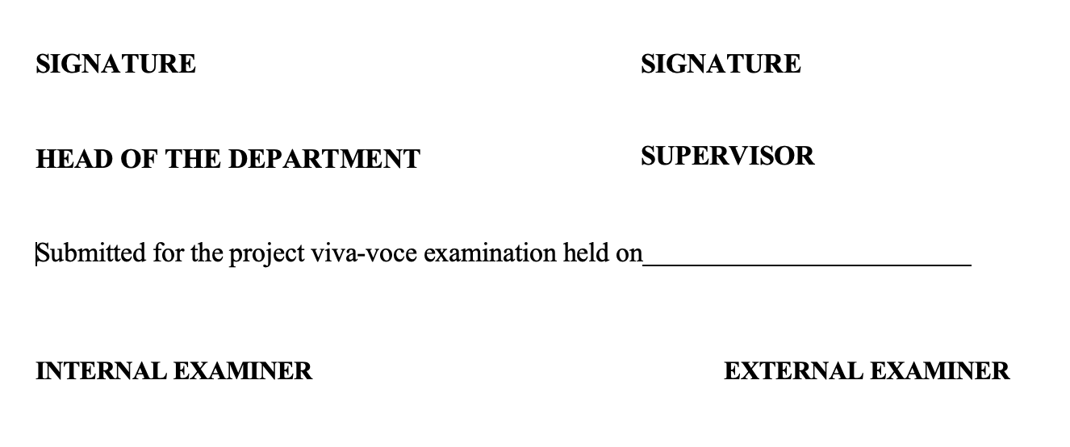

#### Signature of the Student:

 

**TABLE OF CONTENT**

|  |  |  |
| --- | --- | --- |
| Sr no. | Topic | Page No. |
| 1 | INTRODUCTION | 4-5 |
| 2 | LITERATURE REVIEW/BACKGROUND STUDY | 6-8 |
| 3 | DESIGN FLOW/PROCESS | 9-11 |
| 4 | RESULTS ANALYSIS AND VALIDATION | 12-18 |
| 5 | CONCLUSION AND FUTURE WORK | 19 |

# ABSTRACT

FOOD ORDERING SYSTEM:

Our proposed system is an ONLINE FOOD ORDERING SYSTEM (ItallianVilla) that enables ease for the customers. it Overcomes the disadvantages of the traditional queueing system. Our proposed system is a medium to order online food hassle free from restaurants as well as mess service. This system improves the method of taking the order from customer. The online food ordering system sets up a food menu online and customers can easily place the order as per their wish. Also with a food menu, customers can easily track the orders. This system also provides a feedback system in which user can rate the food items. Also, the proposed system can recommend hotels, food, based on the ratings given by the user, the hotel staff will be informed for the improvements along with the quality. The payment can be made online or pay-on-delivery system. For more secured ordering separate accounts are maintained for each user by providing them an ID and Password. It is mainly designed primarily function for use in the food delivery industry. This system will allow hotels and restaurants to increase online food ordering such type of business. The customers can select food items from menu just in few minutes. A food ordering application that consists of modules for the chef, the customer, and the delivery person, will be developed by us. It is a software with elements consisting of a sign-in page, registration chores with to be had meals items, details about the restaurants and the order status, to add dishes to the cart and the status of deliveries. All of these features are made by us, and the code is written in a variety of languages, such as JavaScript, HTML, Node.js, MySQL, CSS. We utilized XAMPP and MVC framework as well for better functionality and working status. A set of comprehensive development tools are featured in a software development kit (SDK). These help you develop your application efficiently.

# CHAPTER 1.

**INTRODUCTION**

## Client Identification/Need Identification/Identification of relevant Contemporary issue:

Our motivation for creating this app stemmed from the fact that my family works in the fast-food industry, and we dislike waiting in lines or having to call ahead to place an order, especially during peak lunch or dinner hours. In addition, we value our current knowledge of the NodeJS, MongoDB and ES6 programming languages, as well as understanding how strong and dynamic they are when it comes to web design and application development. Because we found them to be highly beneficial when working on the technologies, we used JavaScript, Bootstrap, HTML, CSS and NodeJS to develop this application on the client side, and MongoDB database on the back end.

## Identification of Tasks:

The main objective of the Project on Online Food Ordering System is to manage the details of Food Item, Category, Customer, Order, Confirm Order. It manages all the information about Food Item, Payment, Confirm Order, Food Item. The project is totally built at administrative end and thus only the administrator is guaranteed the access. The purpose of the project is to build an application program to reduce the manual work for managing the Food Item, Category, Payment, Customer. It tracks all the details about the Customer, Order, Confirm Order.

## Timeline and Block Diagram of the Project:

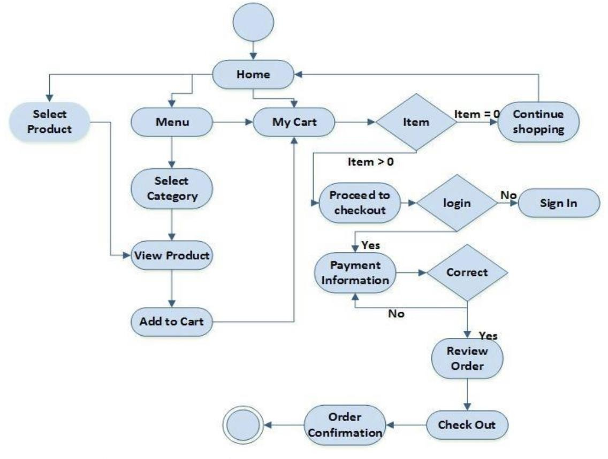

#### Fig: 1.3.1

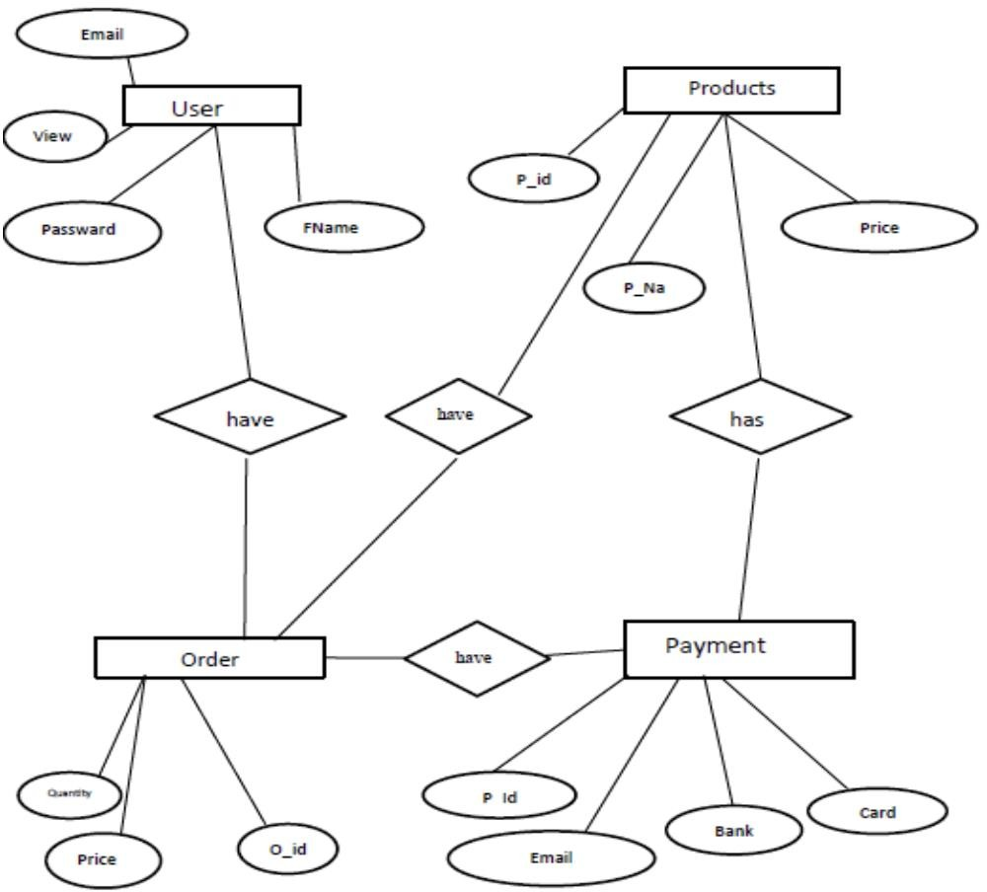

**Fig 1.3.2**

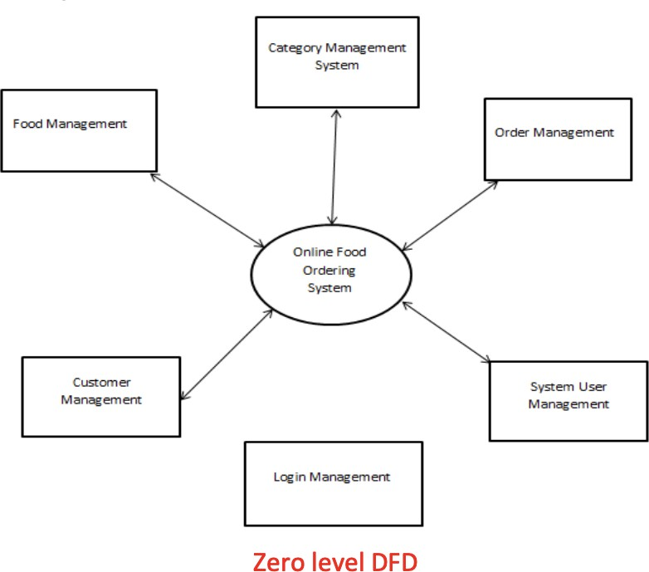

#### Fig 1.3.3

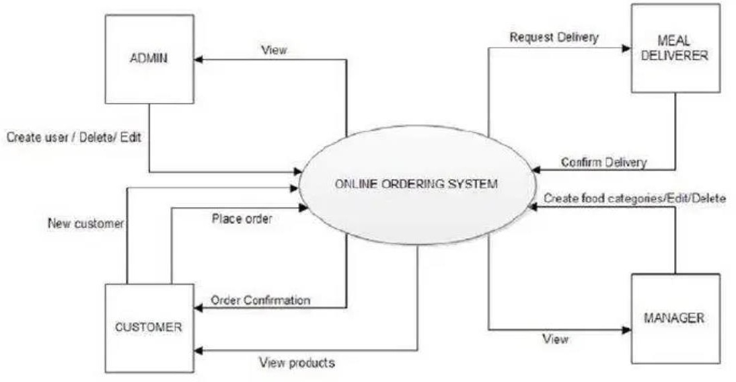

**Fig 1.3.4**

## Organization of the Report:

In the following chapters there, the reader will get to know about the Literature survey of the project and the flow of the application that how it’s been taking the data from the user and how it is differentiating between the user and the client. The working of the API and the database tables which have been used to carry out the proper working of the project.

# CHAPTER 2.

**LITERATURE REVIEW/BACKGROUND STUDY**

## Timeline of the reported problem

With the increase in the use of internet from when it was developed to today when it has become a major part in our lives security and the ability to distinguish between different user’s has been a major thing. Means when the boom in the internet industry has just begun everyone started going online. Everyone was making a website for their businesses doesn’t matter if they were small or big. So, with online web application there are two main things: One is the client who’s will be using the application and; Second is the admin who will update the contents of the website of any application in the matter. So, the developer has to find a way to distinguish between the client users and admin users from there information because the admin will have some additional rights and some extra access to the information which the user will not have so, the need for user management can into consideration. User management is just a part of the project, it’s a module in itself that serves in the entire application. That application can be restaurant management system, library management system or university management system etc. Because all these examples have users some are just clients and the other few are also there who have admin rights.

Given below are the research papers used for our analysis whilst considering various approaches. In [1] along with customer feedback for a restaurant a design and execution of wireless food ordering system was carried out. It enables restaurant owners to setup the system in wireless environment and update menu presentations easily. Smart phone has been integrated in the customizable wireless food ordering system with real- time customer feedback implementation to facilitate real- time communication between restaurant owners and customers. In Paper [2], the purpose of this study was to investigate the factors that influence the attitude of internet users towards online food ordering in Turkey among university students. A Technology Acceptance Model (TAM) developed by Davis in 1986 was used to study adoption of Web environment for food ordering. Trust, Innovativeness and External Influences are added to the model as main factors along with TAM. In Paper [3], the research work aims to automate the food ordering process in restaurant and also improve the dining experience of customers. Design implementation of food ordering system for restaurants were discuss in this paper. This system implements wireless data access to servers. The android application on user’s mobile will have all the menu details. Kitchen and cashier receive the order details from the customer mobile wirelessly. These order details are updated in the central database. The restaurant owner can manage the menu modifications easily.

In Paper [4], this research works on efforts taken by owners of restaurants to adopt information and communication technologies such as PDA, wireless LAN, costly multi-touch screens, etc. to

enhance dining experience. This paper highlights some of the limitations of the conventional paper based and PDA-based food ordering system and proposed the low-cost touch screen- based Restaurant Management System using an android Smartphone or tablet as a solution. In Paper [5], the purpose of the study was the application is based on user’s requirement and is user cantered. All issues related to all user which are included in this system are developed by this system. If people know how to operate android smart phone wide variety of people can use the application. This system will solve the various issues related to Mess service. To help and solve important problems of people implementation of Online Food Ordering system is done. It can be concluded that, based on the application: Orders are made easily by this system; Information needed in making order to customer is provided by the system. Receiving orders and modifying its data is possible through the application and it also helps admin in controlling all the Food system

## Proposed solutions

A solution to this problem is to design a user management module that distinguishes between the user and admin. This will help in security and integrity of the data that will be there in the application. For this the application has to use this module before any of the functionality that has been provided by that application.

* + - *It generates the report on Food Item, Category, Payment.*
    - *Provide filter reports on Customer, Order, Confirm Order.*
    - *You can easily export PDF for the Food Item, Payment, Order.*
    - *Application also provides excel export for Category, Customer, Confirm Order.*
    - *You can also export the report into csv format for Food Item, Category, Confirm Order.*

## Bibliometric analysis

After the completion of this project the distinction between the user and the admin will be seen as there will be some functionality that has been removed for the user but it exists in the application but for that user only who’s ROLE: ADMIN specified in the database. The user having ROLE: CLIENT will not be able to see that functionality and therefor will not be able to alter the data. Also, the user having ROLE: CLIENT will not be able to open that web page after copying the URL and signing into the application the security feature should also be there.

None of the constituent system components will be deployed as embedded applications, according to the SRS. The implication is that the target hardware will be capable of deploying standalone programs/applications without the need for bespoke embedded firmware. Tablet PCs with suitable computing capability and battery life are also expected to be used. The system's surface computers should be able to be used/left on for long periods of time (enough for daily use) and be programmable in the same way as x86 architecture computers are. Finally, for system

communication, it is anticipated that the deployment environment can handle an IEEE 802.11 wireless network.

## Review Summary:

The problem which that has been addressed in the starting of this section is resolved with this project. There is a clear distinction between the USER and ROLE: CLIENT and USER having ROLE: ADMIN. The application is able to differentiate automatically between these two roles.

The ONLINE FOOD ORDERING SYSTEM links with a current payment system, which includes a cash register and a software-accessible credit/EFTPOS system, to manage client invoicing quickly and conveniently. The payment system should be able to communicate information about whether or not the payment was successful to the ONLINE FOOD ORDERING SYSTEM.

There are three separate user interfaces in the ONLINE FOOD ORDERING SYSTEM software, each of which is coupled to a physical hardware component (see Section 2.1.3). The three user interfaces accessible are Surface Computer UI, Tablet UI, and Display UI. User Interface Design is concerned with the interaction between a user and a computer. It covers everything from starting the system to logging in to the final presentation of essential inputs and results. The whole flow of screens and communications is referred to as a dialogue. The following are some guidelines for designing a user interface:

1. The system's user should always be aware of what to do next.
2. The screen should be set up so that various types of data, instructions, and messages are always presented in the same general area.
3. Messages, instructions, and other information should be given for the system user to read for a sufficient amount of time.
4. Don't employ display features excessively.
5. User-enterable fields and answers should have default values.
6. If a mistake is found, the user should not be allowed to continue.
7. The system user should never see an operating system notice or a fatal error.

## Problem Definition:

The technology we recommend is an easy-to-use online meal ordering system for customers. It overcomes the disadvantages of traditional queueing systems. Our system is both a convenient way to order food from restaurants and a mess service. The procedure of taking a customer's order is made easier with this technology. Customers may place orders fast utilizing the online meal ordering system, which generates an online menu. Customers can also use a meal menu to keep track of their orders. Users can also rate the food goods using this system's feedback feature. In addition, based on the user's ratings, the proposed system can recommend hotels and meals, and

the hotel staff will be notified of any quality adjustments.

* + - *ADMIN*
      * *Login: Admin has to Login to manage the whole menu part of the website.*
      * *Manage the menu- Admin manages all the menu in the menu section.*
      * *Delete Items- Admin can delete items of menu from database.*
    - *USER*
      * *Login: User has to Login to listen and download the songs.*
      * *Edit Profile: User can view and edit their profile after registering and logging in on the website.*
      * *Registration: This module is accessible by the user to register on the website to access all the features.*

The Use case describes what of a system not “how”. They only give functional view of the system. Use cases are structured outline or templates for the description of user requirement, model in a structured language like English. Use case diagrams are graphical representation that may be decomposed into further levels of the abstraction.

* + - Actor

An Actor models a type of role played by an entity that interacts with the subject (e.g., by exchanging signals and data), but which is external to the subject (i.e., in the sense that an instance of an actor is not a part of the instance of its corresponding subject). Actors may represent roles played by human users, external hardware, or other subjects.

* + - Association

An association specifies a semantic relationship that can occur between typed instances. It has at least two ends represented by properties, each of which is connected to the type of the end. More than one end of the association may have the same type.

* + - System

If a subject (or system boundary) is displayed, the use case ellipse is visually located inside the system boundary rectangle. Note that this does not necessarily mean that the subject classifier owns the contained use cases, but merely that the use case applies to that classifier.

* + - Use Case

A use case is the specification of a set of actions performed by a system, which yields an observable result that, is, typically, of value for one or more actors or other stakeholders of the system.

# CHAPTER 3.

**DESIGN FLOW/PROCESS**

## Evaluation & Selection of Specifications/Features

The physical design relates to the actual input and output processes of the system. This is laid down in terms of how data is input into a system, how it is verified / authenticated, how it is processed, and how it is displayed as output. Physical design, in this context, does not refer to the tangible physical design of an information system. To use an analogy, a personal computer's physical design involves input via a keyboard, processing within the CPU, and output via a monitor, printer, etc. It would not concern the actual layout of the tangible hardware, which for a PC would be a factor.

Model View Controller, or MVC as it is more commonly known, is a software design pattern that is used to construct web applications. The Model View Controller pattern is made up of three parts:

* Model - The lowest level of the pattern, which is responsible for data upkeep.
* View- This is in charge of displaying all or a portion of the data to the user.
* Controller - Software code that manages the Model's and View's interaction.

MVC is popular because it separates the application logic and user interface layer, which allows for responsibility separation. All application requests are accepted by the Controller, which then works with the Model to prepare any data that the View requires. The View then uses the data generated by the Controller to create a final presentable response. The MVC abstraction can be graphically represented as follows. Diagram of MVC (Model View Controller Flow)

* 1. ***monitor, CPU, motherboard, hard drive, modems, video/graphics cards, USB slots, etc.* Design Constraints**

NA

## Analysis and Feature finalization subject to constraints

After this module has been completed the user will be able to register himself/herself with having different roles to test the functionality if its working or not. After logging in if the user is ADMIN, he/she will be able to edit their personal info and if the user is not ADMIN, he/she will only be able to edit their own information only.

## Implementation plan/methodology

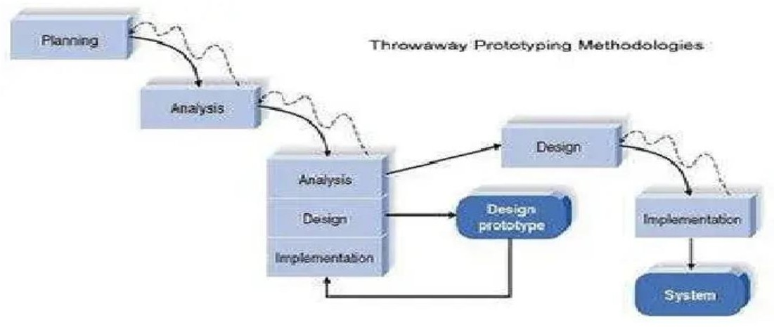

Fig: 3.4.1

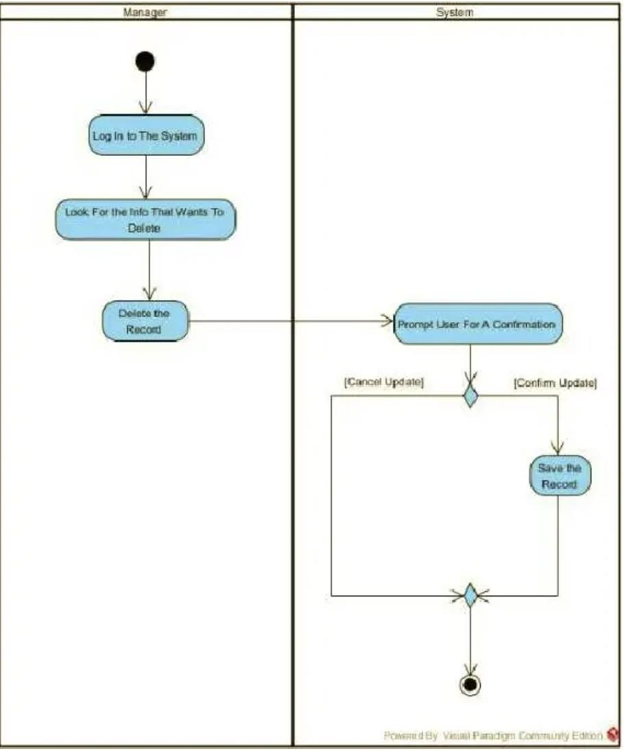

Fig: 3.4.1

# CHAPTER 4.

**RESULTS ANALYSIS AND VALIDATION**

## 4.1. Implementation of solution:

### Bootstrap:

Bootstrap is the most popular HTML, CSS and JavaScript framework for developing a responsive and mobile friendly website. It is absolutely free to download and use. It is a front-end framework used for easier and faster web development. It includes HTML and CSS based design templates for typography, forms, buttons, tables, navigation, modals, image carousels and many others. It can also use JavaScript plug-ins. It facilitates you to create responsive design.

### MongoDB:

MongoDB is an open-source document database built on a horizontal scale-out architecture that uses a flexible schema for storing data. Founded in 2007, MongoDB has a worldwide following in the developer community.

Instead of storing data in tables of rows or columns like [SQL databases](https://www.mongodb.com/nosql-explained/nosql-vs-sql), each record in a MongoDB database is a document described in BSON, a binary representation of the data. Applications can then retrieve this information in a JSON format.

MongoDB is built on a [scale-out architecture](https://www.mongodb.com/basics/scaling) that has become popular with developers of all kinds for developing scalable applications with evolving data schemas.

As a document database, MongoDB makes it easy for developers to store structured or unstructured data. It uses a [JSON-like](https://www.mongodb.com/json-and-bson) format to store documents. This format directly maps to native objects in most modern programming languages, making it a natural choice for developers, as they don’t need to think about [normalizing data](https://www.mongodb.com/basics/data-models). MongoDB can also handle high volume and can scale both vertically or horizontally to accommodate large data loads.

MongoDB was built for people building internet and business applications who need to evolve quickly and scale elegantly. Companies and development teams of all sizes use MongoDB for a wide variety of reasons.

### XAMPP:

XAMPP is an abbreviation for cross-platform, Apache, MySQL, PHP and Perl, and it allows you to build WordPress sites offline, on a local web server on your computer. This simple and lightweight solution works on Windows, Linux, and Mac – hence the “cross-platform” part. XAMPP is an open-source package that is widely used for PHP development. XAMPP contains MariaDB, PHP, and Perl; it provides a graphical interface for SQL (phpMyAdmin), making it easy to maintain data in a relational database. XAMPP is a local server, which runs Apache, Php and MySQL for developing and testing websites and apps on your local machine. It replicates a LAMP web server locally on your laptop/computer

### Node.js:

Node.js is an **open source, cross-platform runtime environment and library** that is used for running web applications outside the client’s browser.

It is used for **server-side programming**, and primarily deployed for non-blocking, event-driven servers, such as traditional web sites and back-end API services, but was originally designed with real-time, push-based architectures in mind. Every browser has its own version of a JS engine, and node.js is built on Google Chrome’s V8 JavaScript engine. Sounds a bit complicated, right?

In simple terms, what this means is that entire sites can be run using a unified ‘stack’, which makes development and maintenance quick and easy, allowing you to focus on meeting the business goals of the project.

The fact that Node.js is open source means that it is free to use and constantly being tweaked and improved by a **global community of developers**.

An important thing to understand about Node.js is that it is actually neither a framework or a library

- as with traditional application software -, but **a runtime environment**.

A runtime environment (sometimes shortened to RTE) contains Web API’s that a developer can access to build a code, and a JavaScript engine that parses that code. This makes it lightweight, flexible and easy to deploy, all features that will help to optimize and speed up your application project.

### JavaScript:

JavaScript often abbreviated as JS, is a programming language that conforms to the ECMAScript specification. JavaScript is high-level, often just-in-time compiled, and multi-paradigm. It has curly-bracket syntax, dynamic typing, prototype-based object-orientation, and first-class functions

XAMPP Control Panel:

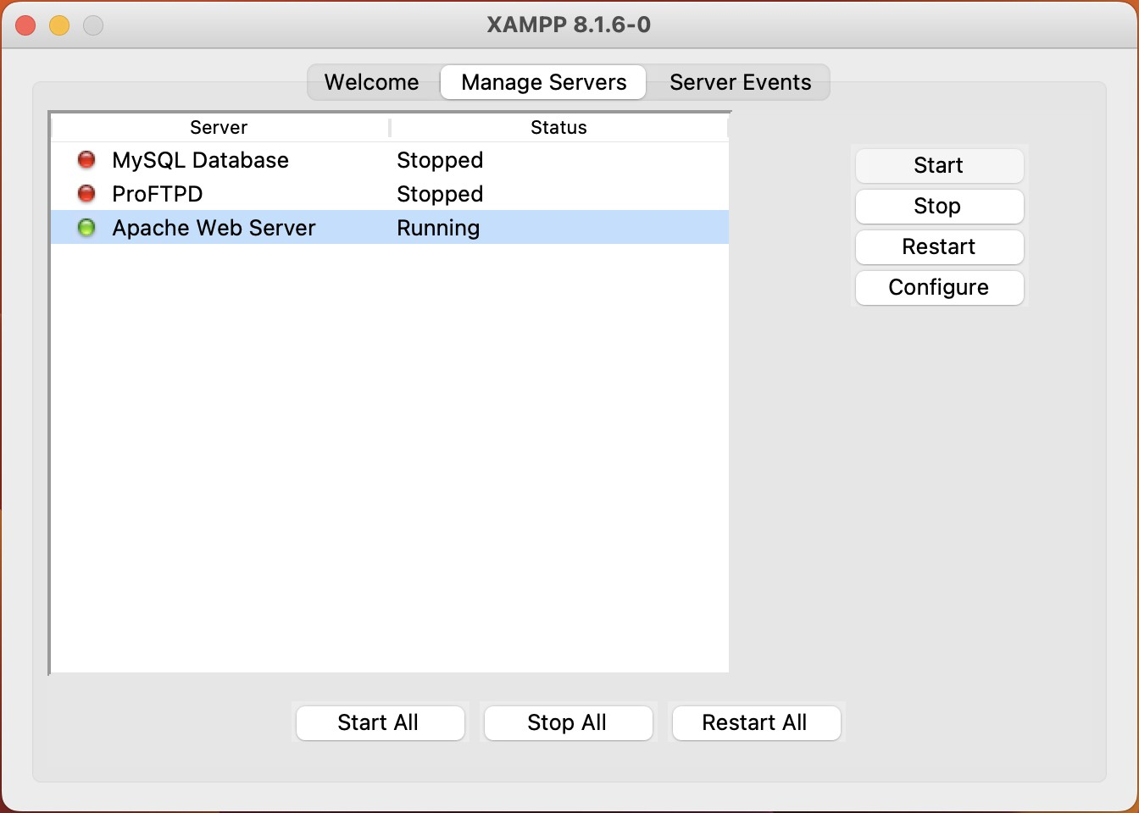

### Fig 4.1.1

MongoDB Database:

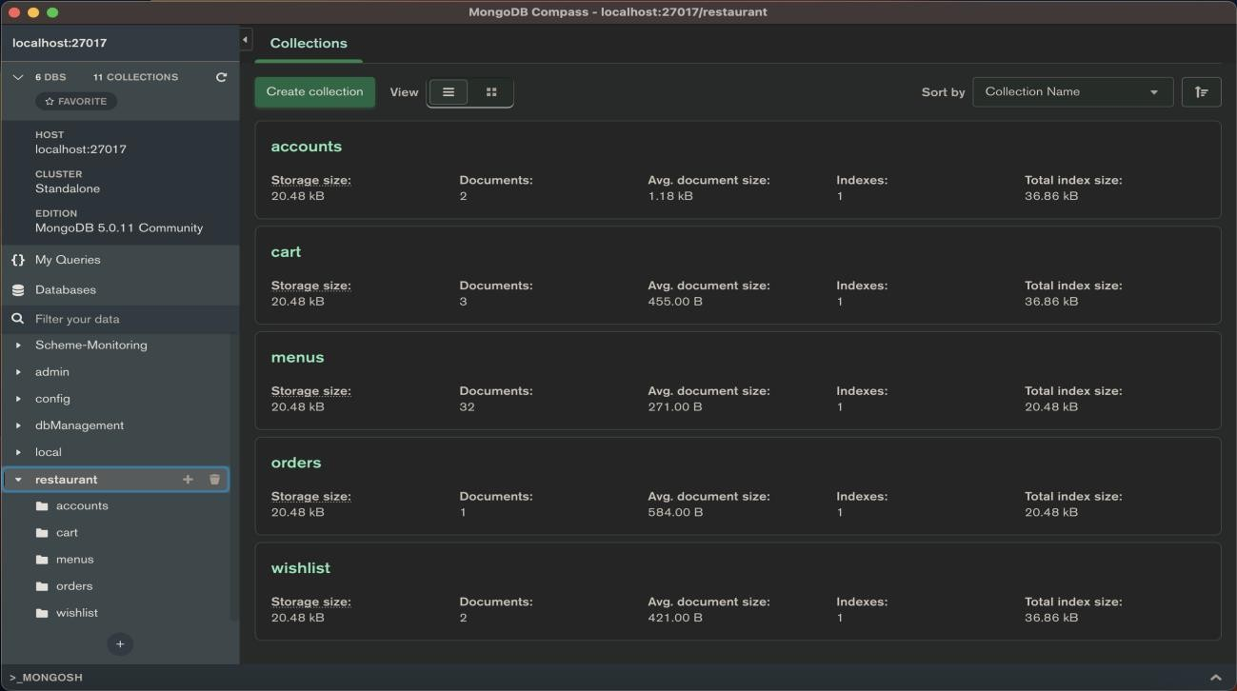

### Fig 4.1.2

Web-Application:

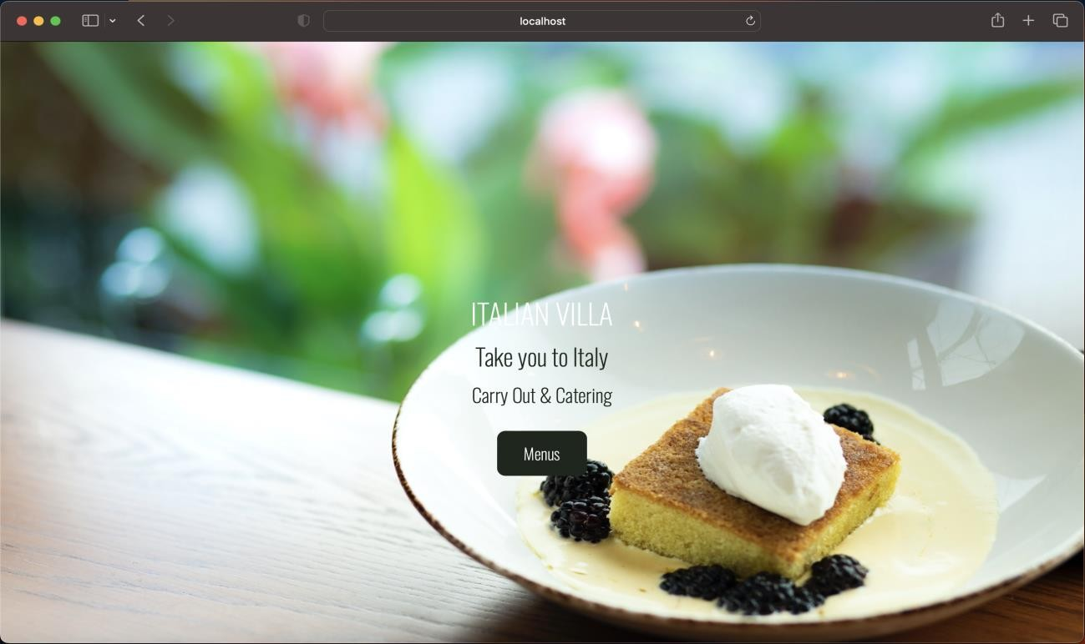

### Fig 4.1.3

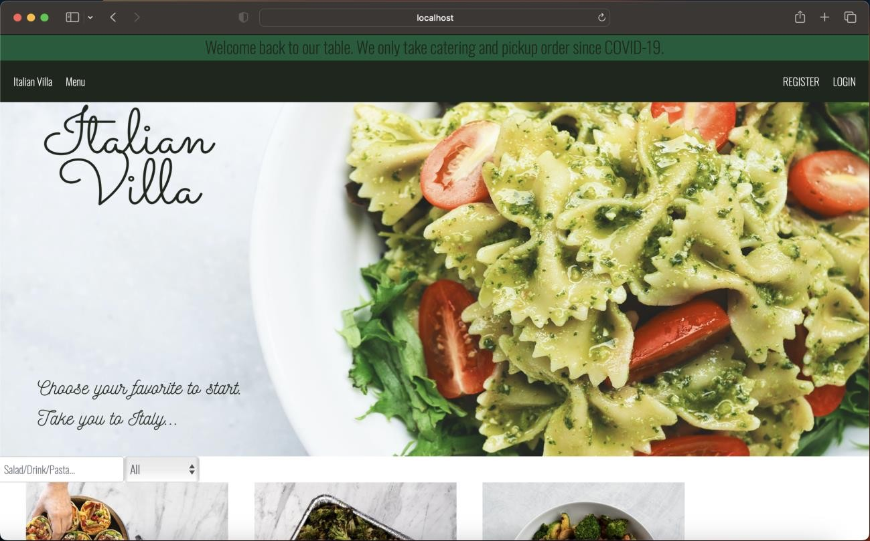

Fig 4.1.4

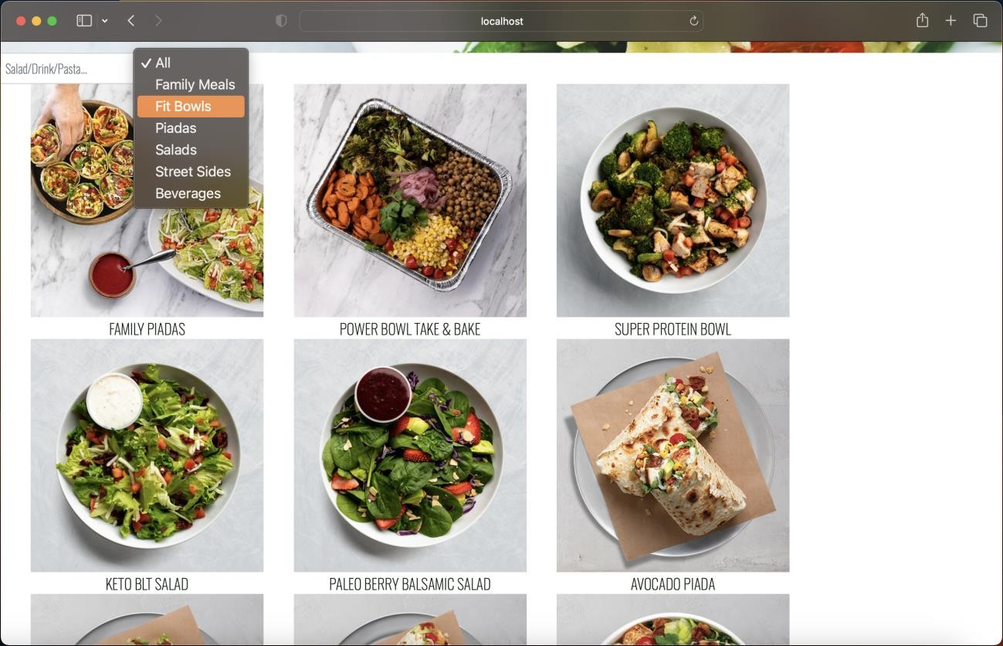

### Fig 4.1.5

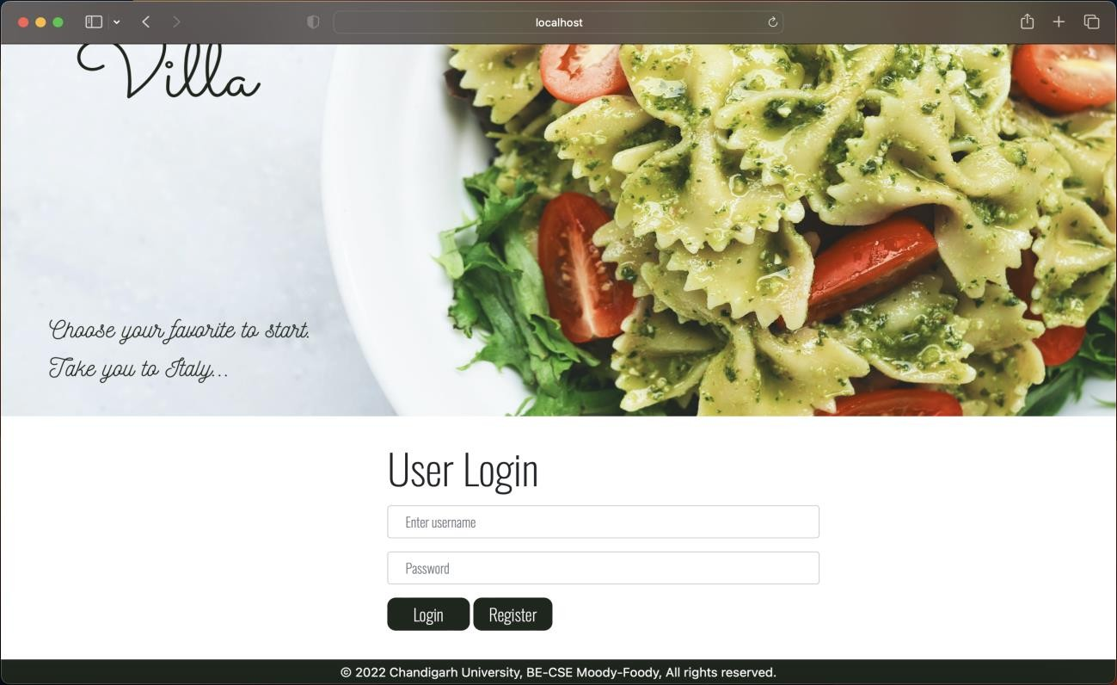

Fig 4.1.6

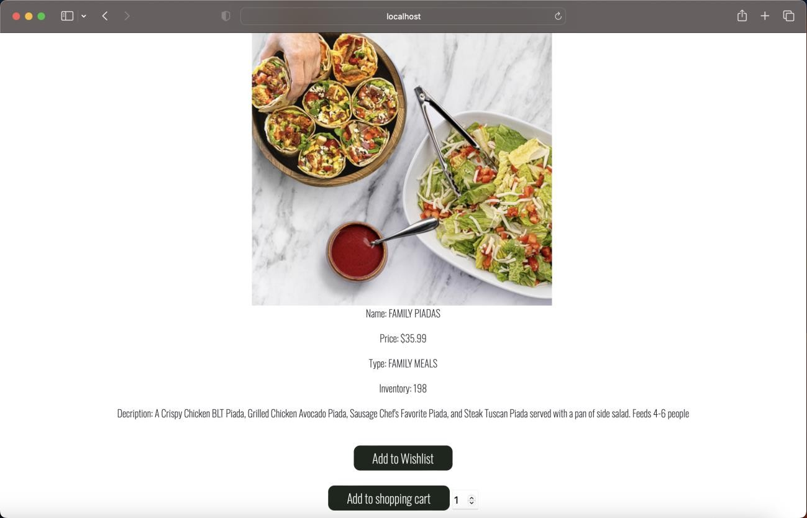

### Fig 4.1.7

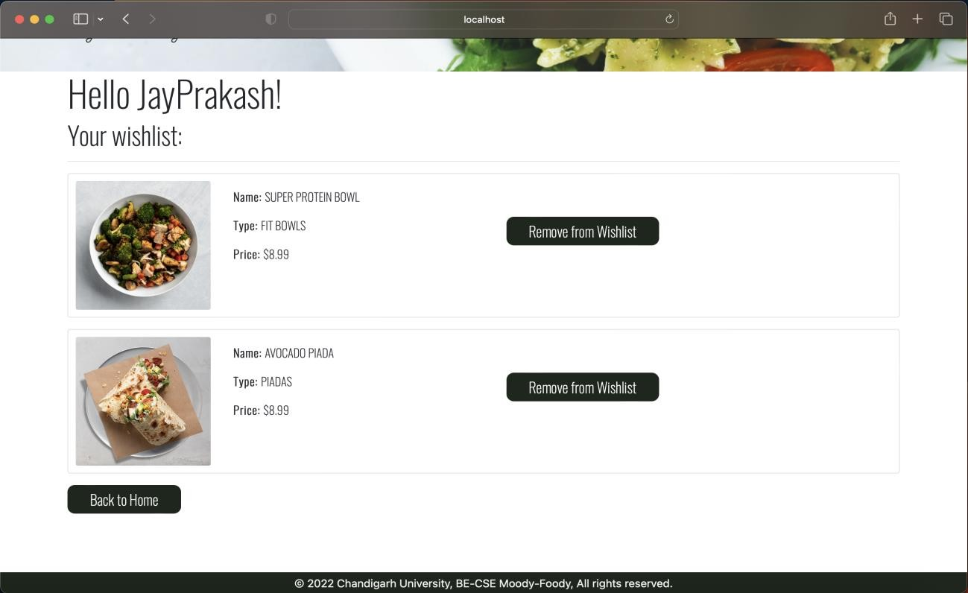

Fig 4.1.8

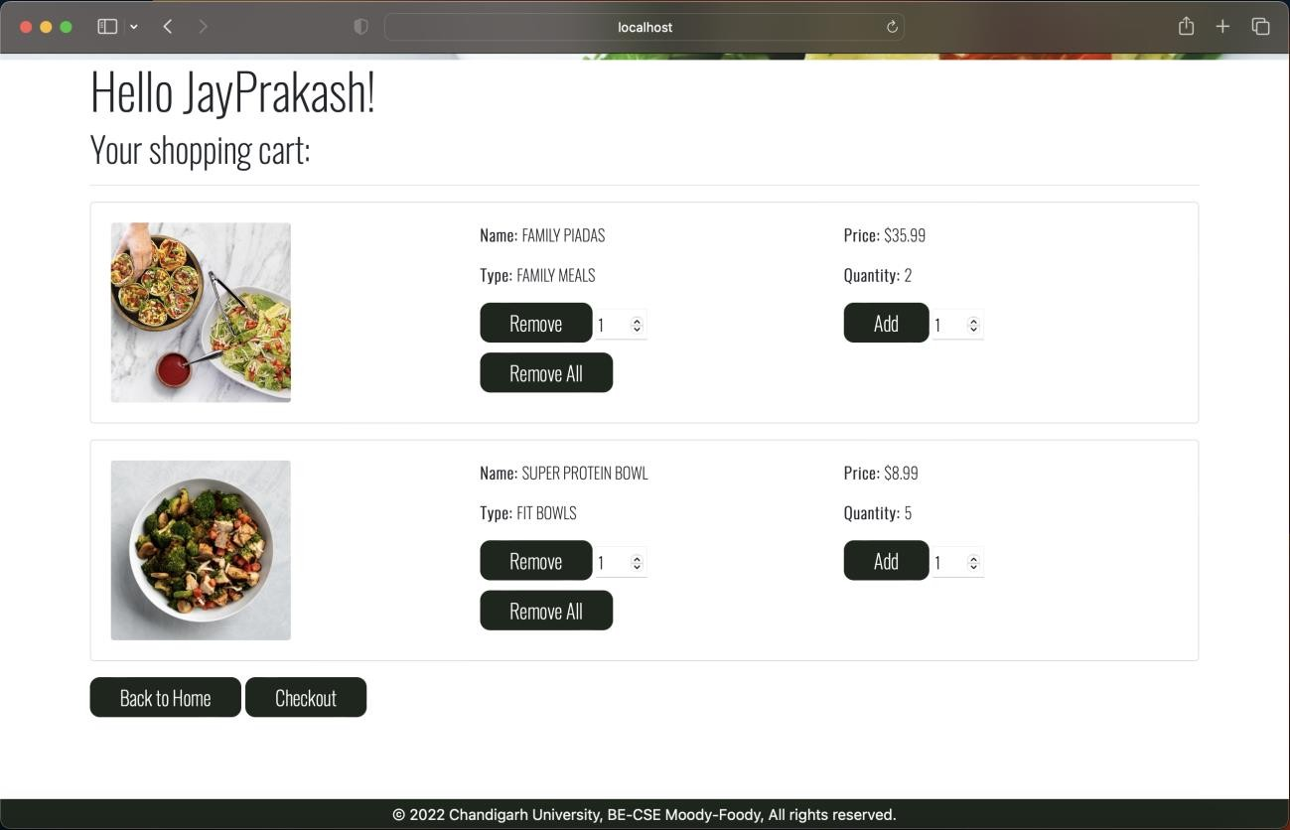

### Fig 4.1.9

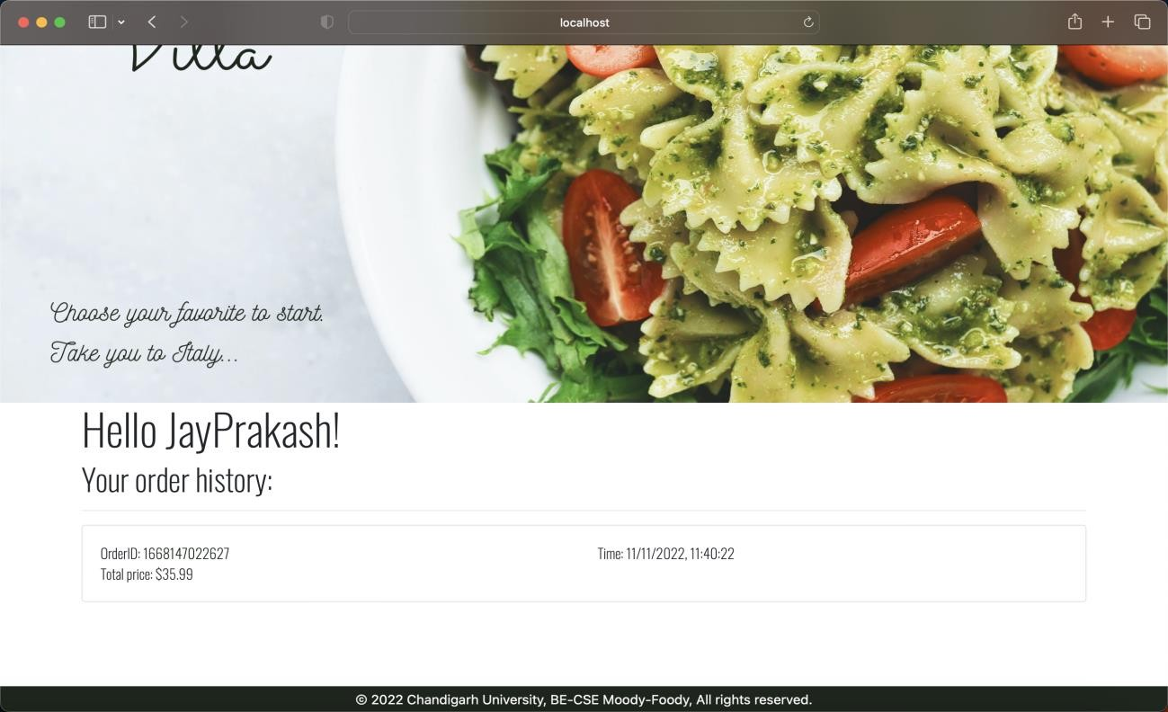

Fig 4.1.10

ADMIN PANEL:

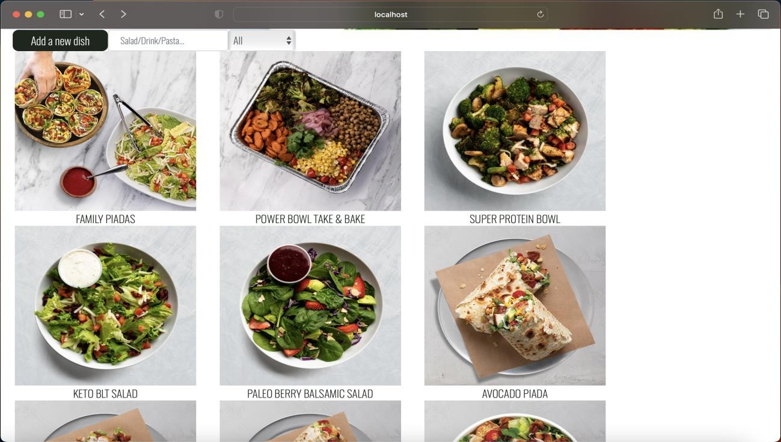

### Fig 4.1.11

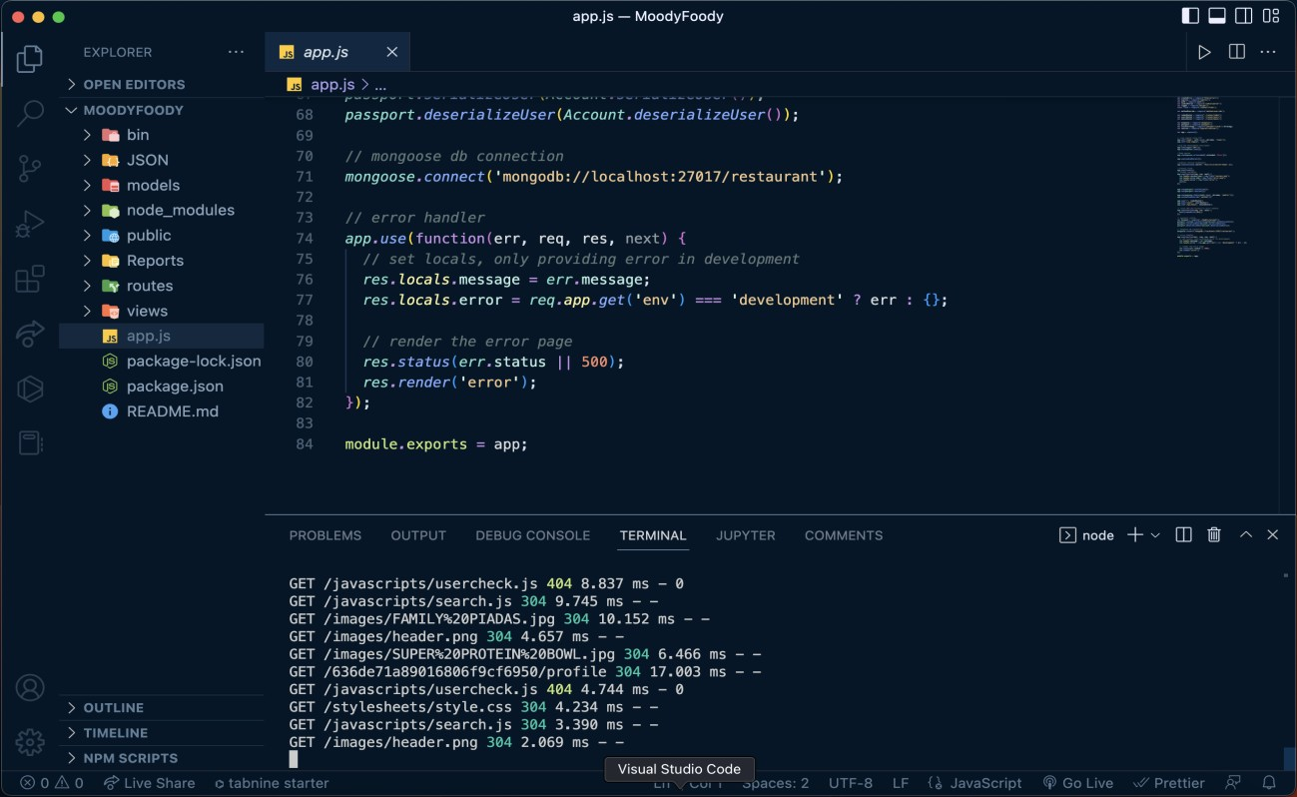VS CODE:

Fig 4.1.12

# CHAPTER 5.

**CONCLUSION AND FUTURE WORK**

## Conclusion

The result of the proposed system was met in the end when the project went live on the localhost server.

## Future work

In the future this module can be used as a part of any major ERP. This module can become a part of Library Management System or an application like Spotify or NETFLIX. This here is just a module that every major application whether related to banking or related to entertainment uses for security and for the ability to distinguish between different user. Those who work in the company and those who use the service provided by the company.

The scope of the proposed project is to provide a simple user management page that lets you view, search users, create new user accounts, and edit existing ones. Also provides tools to disable or delete users, manage permissions, and issue password resets. Adding up, our system will also help in upgrading the already existing system to a new automated one which has the following benefits:

* + - Secure

The data which will be accessed such as the personal details of a customer will be safe and secure.

* + - Cost reduction

Due to the new automated system, reduction of paper work will definitely save expenses of the company as compared to the manual systems

* + - Less time Consuming

Since user won’t have to go to different websites and then determine the best deal it’d be less time consuming and much easier for them.

It could be beneficial for gaining complete information about perfect management. In a short period of time, the collection will be obvious, simple, and sensible. It will let a person understand the previous year's management in a clear and vivid manner. It also helps to finish all existing projects related to the Online Food Ordering System. The cost of collecting the management will be reduced, and the collection process will be more efficient. Our project aims to automate business

procedures, so we've attempted to automate a number of processes in an Online Food Ordering System. A person needs fill out several forms on a computer system, and a huge number of duplicates of the forms can be generated swiftly.

* In a computer system, it is not essential to create the manifest; instead, we can print it directly, saving time.
* Assisting employees in documenting their efforts in their different work areas.
* To make the most of resources by boosting their productivity through automation.
* The system creates a variety of data that can be used for a variety of purposes.
* It satisfies the user's needs.
* Be simple to understand and operate for both the user and the operator
* Have a nice user interface
* Be extendable
* The project was completed on time and on budget.

# REFERENCES

1. *Z. Kai, “Design and implementation of college students' entrepreneurship management system based on B/S structure,” RISTI - Revista Iberica de Sistemas e Tecnologias de Informacao, vol. 2016, no. 17, pp. 102–113, 2016.*
2. *S. R. Bharamagoudar, R. B. Geeta, and S. G. Totad, “Web based student information management system,” International Journal of Advanced Research in Computer and Communication Engineering, vol. 2, no. 6, 2013.*
3. *R. Ahmad and W. Ismail, “Performance comparison of advanced encryption standard-128 algorithms for wimax application with improved power-throughput,” Journal of Engineering Science and Technology, vol. 11, no. 12, pp. 1678–1694, 2016.*
4. *1. "A Secular Shift to Online Food Ordering". TechCrunch. 2015-05-07. Associated Press. "Papa John's hits online ordering milestone." 5 May 2008.*
5. *Soder, Chuck. "Online Ordering System Will Get Bigger Slice of Case Students' Pie." Crane's Cleveland Business News. 14 May 2007.*
6. *The retailer, EY's publication in consumer products and retail sector (Report). EY. January-March 2015. "Why Pizza Giants Want Customers to Click, Not Call, for Delivery". Adage.com. Retrieved January 10, 2016.*
7. *"Delivery Start-Ups Are Back Like It's 1999". The New York Times. Retrieved January 10, 2016.*
8. *"Online food delivery ordering is about to overtake phone ordering in the US*

*- Quartz". Oz.com. Retrieved January 10, 2016.*